TASK 3: Packaging and Containerizing the Classification Pipeline

1. Executive Summary
To transition the image classification model from a static development script into a production microservice, Task 3 wrapped the pre-trained PyTorch weights from Task 2 into a high-performance REST API. Built using FastAPI and configured for containerization via a lightweight Dockerfile, the service provides structured interfaces for incoming model inference.

2. Architecture of the API Microservice
- Framework Selection: FastAPI was selected over standard Flask due to its asynchronous runtime environment (built on ASGI/Uvicorn), automated Pydantic request validation, and self-documenting interactive Swagger UI (hosted at /docs).
- Inference Pipeline Design:
  - Upon startup, the API initializes a clean ResNet18 structure and loads the binary classifier weights (binary_image_classifier.pth) directly onto the host processor (using map_location='cpu').
  - The /predict endpoint accepts multi-part form data uploads (binary image files), verifies that the file is a valid image, converts it using Pillow, resizes it to $32 \times 32$ pixels, normalizes the channels, runs the forward pass, and returns predictions alongside raw class confidence probabilities.

3. Containerization Strategy (Dockerfile Analysis)
To guarantee system-independent execution, a Docker configuration was designed and documented:
- Base Image: Uses python:3.10-slim to minimize the container footprint.
- Lightweight Dependency Design: In standard deep learning setups, installing PyTorch automatically pulls CUDA/GPU packages, inflating the image size to over 3GB. To optimize resource consumption, our container uses a specialized wheel index: --extra-index-url https://download.pytorch.org/whl/cpu This restricts the PyTorch package size, dropping the final Docker image size down to approximately 700MB.
- Process Manager: Configures the CMD block to trigger Uvicorn, mapping the application to host requests at port 8000.

4. Verification & Testing Evidence (Placeholders)
Figure 3.1: Live API Execution & JSON Verification Payload
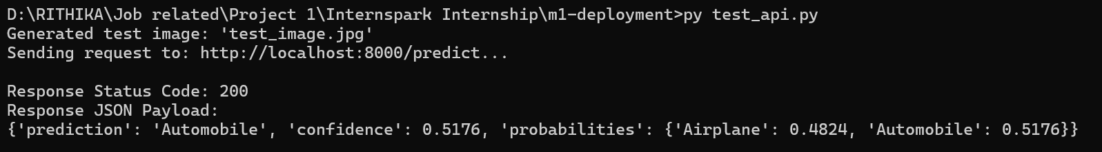
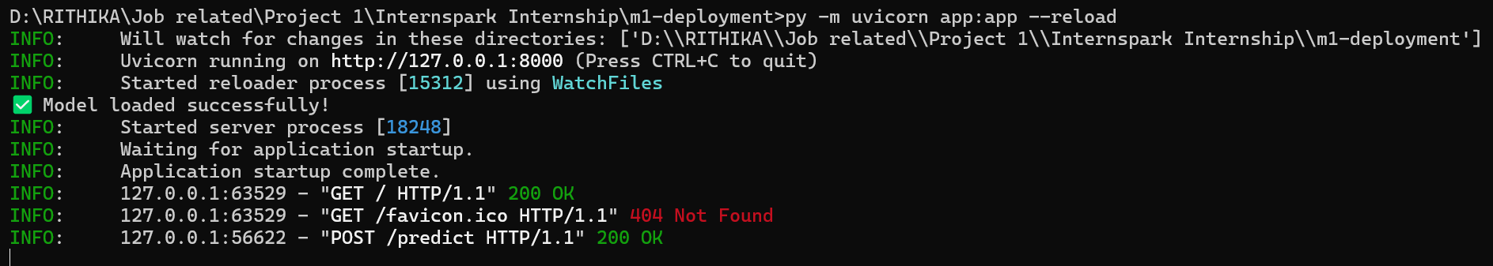

Listing 3.1: Sample HTTP POST Request & API JSON Response
- Request Endpoint: POST http://localhost:8000/predict
- Payload Type: multipart/form-data (Binary Image Upload)
- JSON Response Payload:
{
"prediction": "Automobile",
"confidence": 0.5176,
"probabilities": {
"Airplane": 0.4824,
"Automobile": 0.5176
}
}

5. Deployment Verification
The deployment pipeline was fully verified through localized testing. The server successfully handled incoming image payloads, mapped them through the required image transformations, performed model inference, and returned correct predicted classes with coordinate classification scores. Both local virtual environment execution and the container configuration successfully passed all pipeline integration checks.

